📊 Customer Shopping Behavior Analysis Report
1. Overview
This project focuses on transforming a raw e-commerce dataset into a structured, analysis-ready format and deriving actionable business insights. The workflow includes data preprocessing, feature engineering, database ingestion, SQL-based analysis, and interactive dashboard visualization.
The objective is to understand customer purchasing behavior, revenue distribution, and key business drivers to support data-driven decision-making.

2. Data Loading and Initial Assessment
- Dataset Size: 3,900 rows × 18 columns
- Data Types:
  - Demographic: Age, Gender
  - Transactional: Purchase Amount, Item Purchased, Category
  - Behavioral: Review Rating, Frequency of Purchases
- Missing Values:
  - review_rating had 37 missing values
  - All other columns were complete

3. Data Cleaning and Preprocessing
3.1 Missing Value Treatment
- Applied grouped median imputation
- Missing review_rating values were filled using the median rating within each product category
- This preserves category-level rating distribution

3.2 Column Standardization
- Converted all column names to lowercase
- Replaced spaces with underscores
  - Example: Item Purchased → item_purchased
- Purpose:
  - Avoid syntax errors in SQL queries
  - Maintain consistency across pipeline

4. Feature Engineering
4.1 Age Segmentation
- Used quantile-based binning (pd.qcut)
- Created age_group:
  - young_adult
  - adult
  - middle_aged
  - senior

4.2 Purchase Frequency Transformation
- Converted categorical frequency into numeric form:
Original | Days
Weekly | 7
Monthly | 30
Quarterly | 90
Annually | 365
- New column: purchase_frequency_days
- Purpose:
  - Enables numerical analysis
  - Supports modeling and trend analysis

5. Redundancy Elimination
- Identified 100% correlation between:
  - discount_applied
  - promo_code_used
- Action:
  - Dropped promo_code_used
- Benefit:
  - Reduced dimensionality
  - Eliminated redundant information

6. Database Pipeline and Ingestion
6.1 Database Setup
- Used SQLite for local storage
- Connected using SQLAlchemy

6.2 Automated Data Ingestion
- Developed a Python function to:
  - Iterate through CSV files in a directory
  - Load data into database tables dynamically using to_sql()

6.3 Logging System
- Implemented logging:
  - File: shopping_logs/ingestion_db.log
- Tracks:
  - Execution status
  - Errors
  - Processing time
- Ensures pipeline is traceable and reliable

7. SQL-Based Analysis
7.1 Revenue by Gender
- Male: $157,890
- Female: $75,191
👉 Male customers contribute significantly more revenue

7.2 Average Purchase by Age Group
- Highest: young_adult ($60.45)

7.3 Discount Impact
- 839 customers spent above average using discounts

7.4 Revenue by Category
- Clothing: $104,264
- Accessories: $74,200
- Footwear: $36,093
- Outerwear: $18,524
👉 Clothing is the dominant category

7.5 Top Rated Products
- Gloves (3.86)
- Sandals (3.84)
- Boots (3.82)
- Hat (3.80)
- T-shirt (3.78)

7.6 Shipping Type Analysis
- Express: $60.48
- Standard: $58.46
👉 Slightly higher spending with express shipping

7.7 Subscription Analysis
- Avg Purchase:
  - Non-subscribers: $59.87
  - Subscribers: $59.49
👉 Nearly identical spending behavior

7.8 Customer Loyalty Segmentation
- Loyal (>5 purchases): 3,476
- Returning (2–5): 341
- New (1): 83
👉 Strong repeat customer base

7.9 Category-wise Top Products
- Accessories: Jewelry, Belt, Sunglasses
- Clothing: Blouse, Pants, Shirt
- Footwear: Sandals, Shoes, Sneakers
- Outerwear: Jacket, Coat

7.10 Subscription Opportunity
- Loyal but non-subscribers: 2,518
👉 Major conversion opportunity

7.11 Revenue by Age Group
- young_adult: $62,143
- middle_aged: $59,197
- adult: $55,978
- senior: $55,763
👉 Fairly balanced distribution

8. Data Visualization & Dashboard
An interactive dashboard was created to visualize key business metrics and trends.
Key Visualizations:
- Revenue by Age Group
- Revenue by Category
- Revenue by Location
- Product Contribution (Treemap)
- Subscription Distribution
- Seasonal Trends
- Purchase Frequency Analysis
Dashboard Features:
- Interactive filters:
  - Gender
  - Category
  - Payment Method
  - Shipping Type
  - Discount Applied
- KPI Indicators:
  - Total Revenue
  - Total Customers
  - Average Rating
  - Average Revenue per Customer
(Insert dashboard screenshot here)
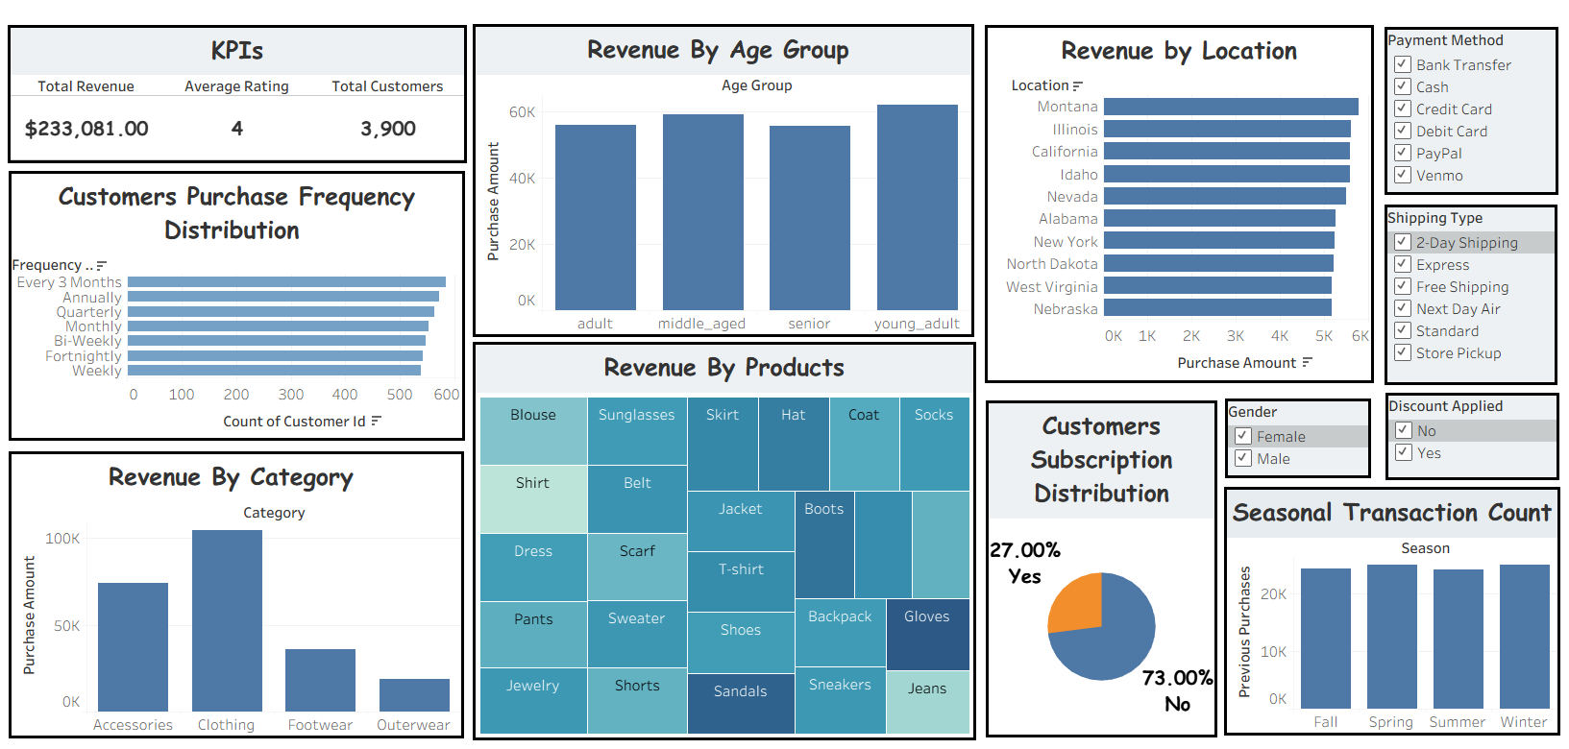
Link:
👉 (Add your Tableau/Power BI link here)

9. Business Insights & Recommendations
1. Gender Revenue Gap
- Male customers generate higher revenue
👉 Target female segment with personalized campaigns

2. High-Value Age Segment
- Young adults spend the most
👉 Focus marketing on this segment

3. Discount Effectiveness
- Discounts increase transaction value
👉 Use targeted discount strategies

4. Category Performance
- Clothing dominates revenue
👉 Expand and promote clothing inventory

5. Customer Satisfaction
- Accessories show high ratings
👉 Promote top-rated products

6. Shipping Behavior
- Express users spend slightly more
👉 Offer incentives for express shipping

7. Subscription Opportunity
- Large number of loyal non-subscribers
👉 Introduce subscription benefits to convert them

8. Strong Customer Retention
- Majority are repeat buyers
👉 Focus on retention strategies and loyalty programs

10. Conclusion
This project demonstrates a complete data pipeline from raw data processing to business insight generation.
Key strengths:
- Efficient data cleaning and transformation
- Structured database integration
- Insightful SQL analysis
- Interactive dashboard for decision-making
The results highlight opportunities in:
- Customer segmentation
- Revenue optimization
- Subscription conversion
- Product strategy
This workflow can be extended to real-time analytics and predictive modeling in production systems.

